Porsche group
Peter Nyamu 155390
Kimberly Wanjiru 159745
Joy Senetwo 157463
Joe Ndeto 169686
Jesse Mbugua 149540
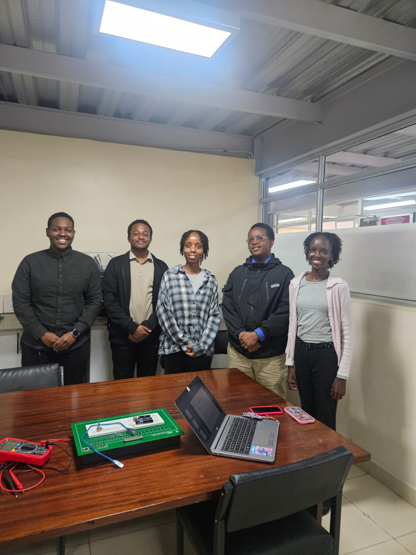

Experiment 1
1.1 47ohms +-5%
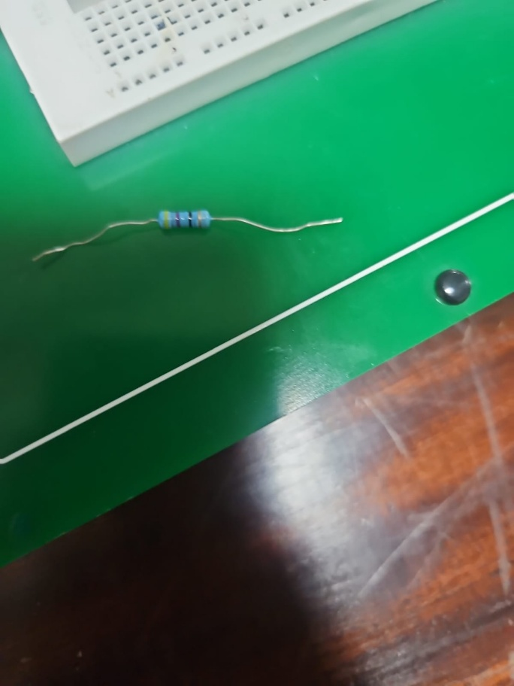
1.2
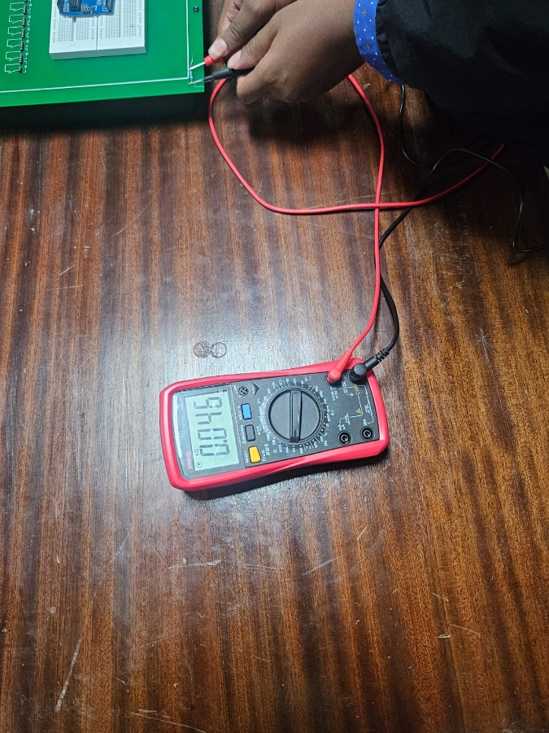
The resistance values differ from expected value to actual value due to manufacturing variations, tolerance ranges where the colour code is represents the expected value, and environmental factors where the resistance may fluctuate due to ambient temperatures.

Experiment 2
2.1
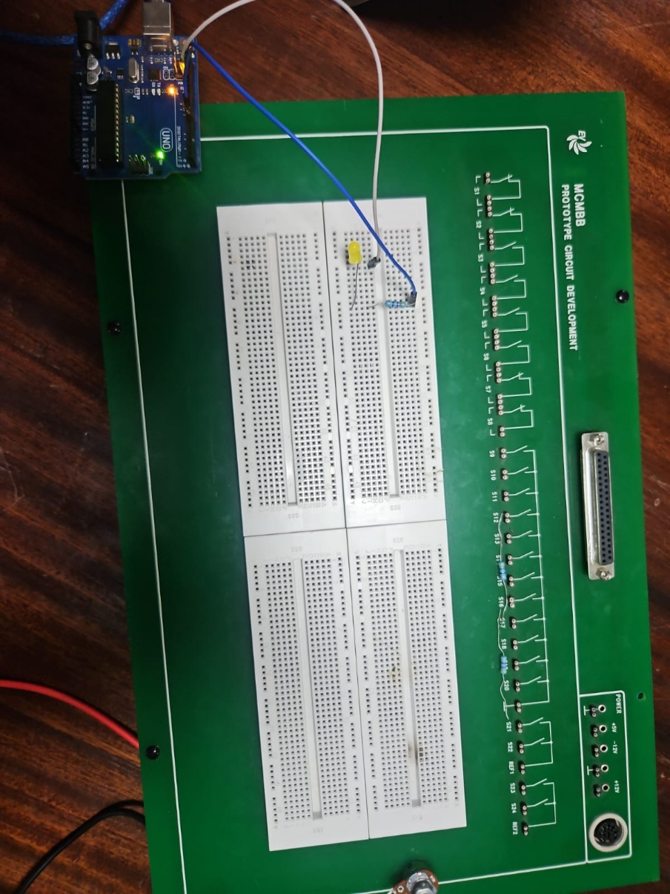
2.3
1.342v
2.4
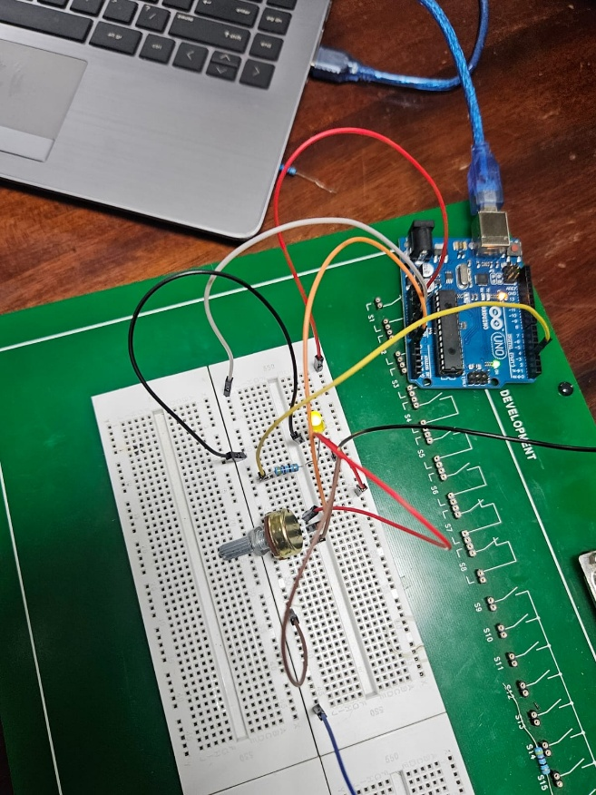
100% brightness
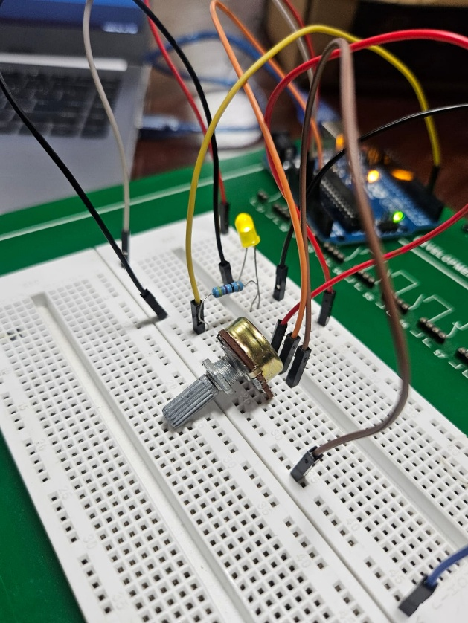

50% brightness
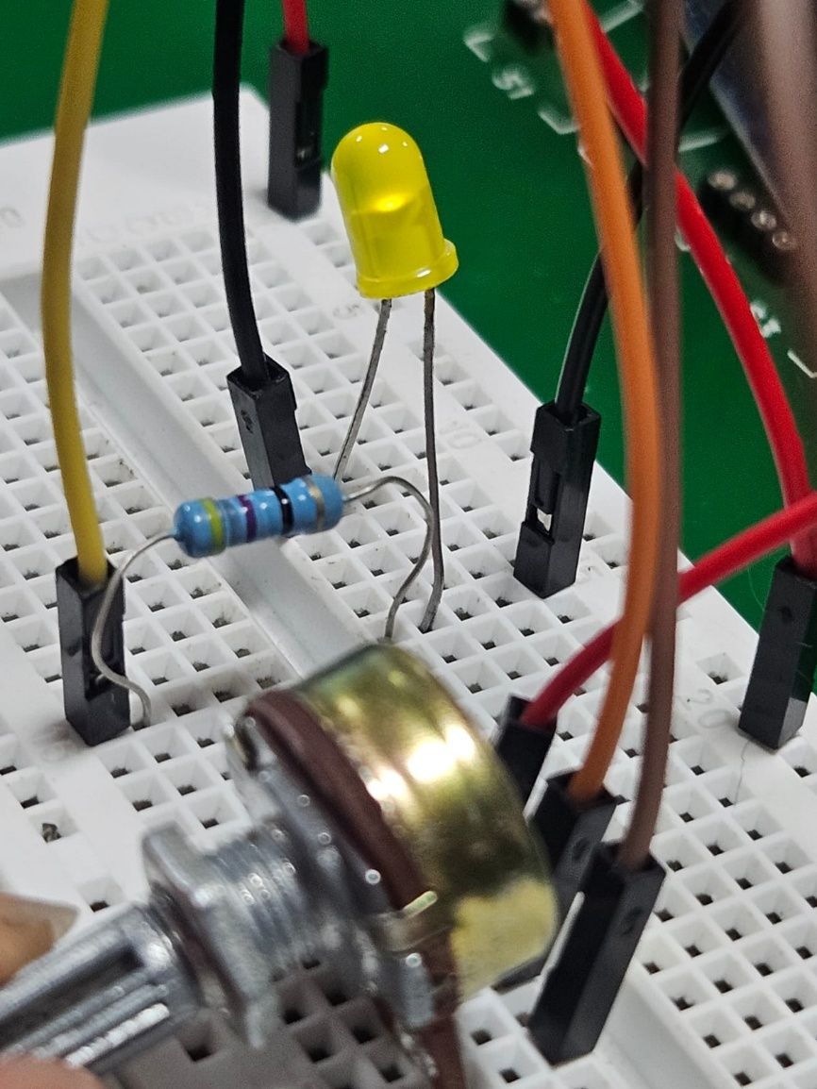
25% brightness

Experiment 3
3.1
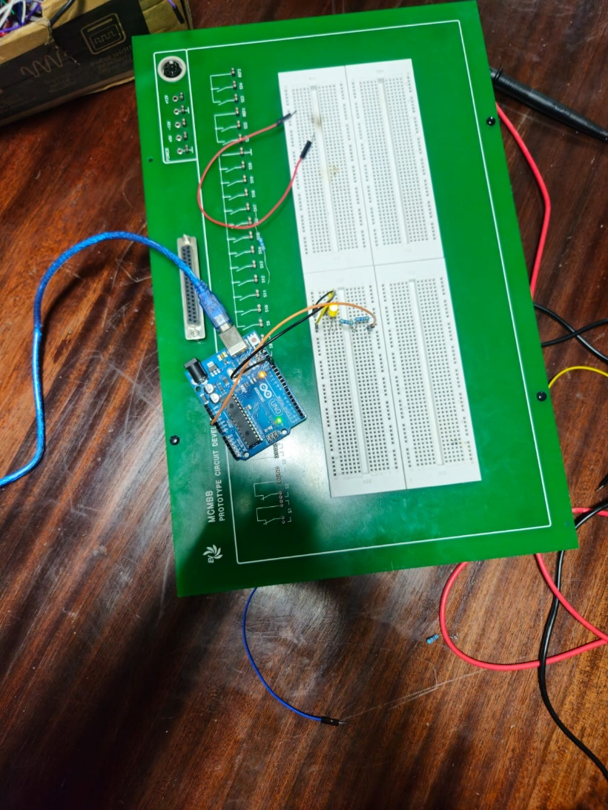

3.3
R₁ – 2.838v
R₂ – 2.838v

I = V/R
= 2.838/46
= 61.7mA for both resistors

Experiment 4
4.1
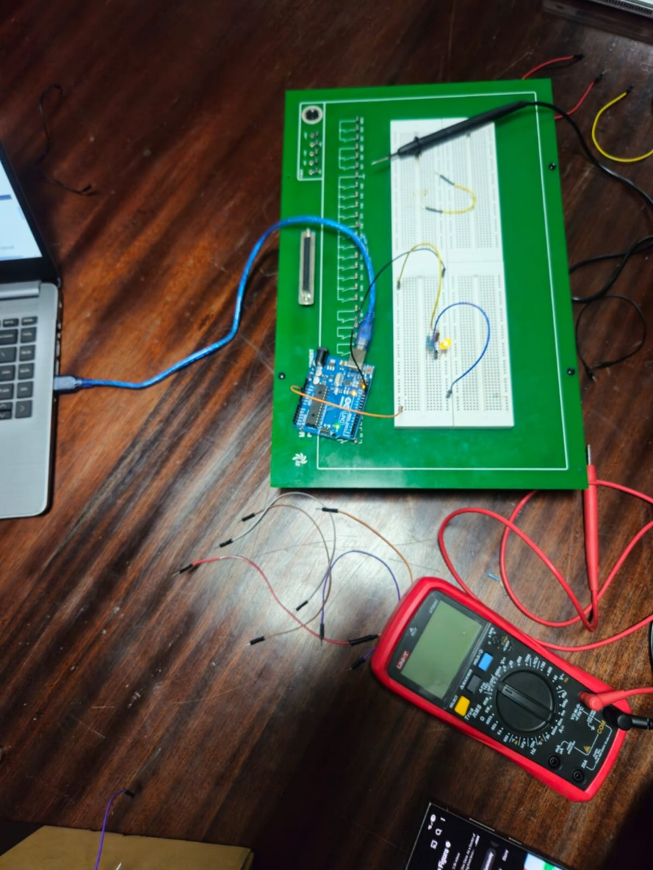
4.3
R₁ – 3.78v
R₂ – 3.72v
Current = V/R
I₁ = 3.78/46
= 0.0822A
I₂ = 3.72/46
=0.0809A

